**Project Design Phase**

**Problem – Solution Fit Template**

| Date | 27 June 2025 |
| --- | --- |
| Team ID | LTVIP2025TMID59202 |
| Project Name | SmartSDLC – AI-Enhanced Software Development Lifecycle |
| Maximum Marks | 2 Marks |

**Problem – Solution Fit Template:**

The SmartSDLC framework addresses the inefficiencies of traditional Software Development Lifecycles when applied to AI and machine learning projects. Conventional SDLC models are not optimized for iterative data workflows, frequent model tuning, or continuous deployment. SmartSDLC introduces automation, intelligence, and agility at each phase—data collection, preprocessing, model building, testing, and deployment—allowing faster feedback, adaptive development, and improved reliability. By integrating MLOps practices with agile sprint planning, it ensures efficient use of resources, reduces time-to-market, and aligns better with the evolving needs of modern AI-driven businesses.

**Purpose:**

* Solve complex ML development issues with a structured and intelligent workflow.
* Increase adoption by aligning with existing agile and DevOps behaviors.
* Sharpen communication between developers, data scientists, and stakeholders.
* Improve delivery speed and product quality with continuous feedback loops.
* Build trust and reliability through real-time testing and monitoring.
* Enhance scalability and flexibility of AI product development.

**Template:**

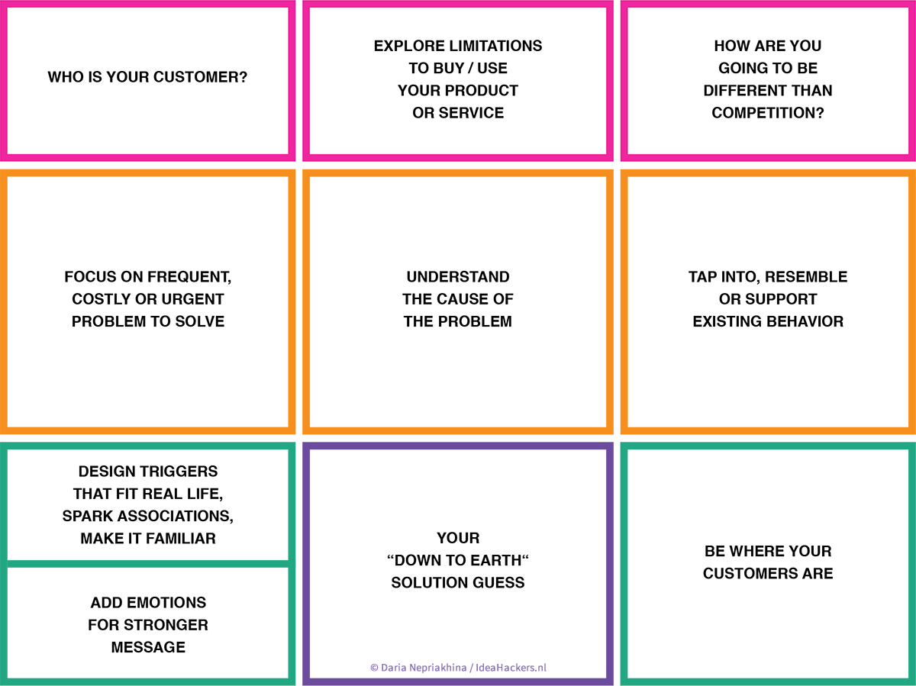

References:

1. <https://www.ideahackers.network/problem-solution-fit-canvas/>
2. <https://aws.amazon.com/blogs/apn/transforming-the-software-development-lifecycle-sdlc-with-generative-ai/>